**Student(s) Name: Efe Şencan**

**CS412 Machine Learning**

# HW 3 – Text Classification: Logistic Regression and Naive Bayesian

# 100pts

* **Please TYPE your answer.**
* **Use this document to type in your answers** (rather than writing on a separate sheet of paper), to keep questions, answers and and grades together so as to facilitate grading.
* **SHOW all your work for partial/full credit.**

**Goal**:

1. By using gaussian distributed artificial dataset with two cluster, makes the decision boundary and conditional independence assumption clearer.
2. The dataset contains around 200k news headlines from the year 2012 to 2018 obtained from HuffPost, make a classification of 5 hot topics by Naive Bayesian and Logistic Regression.

**Grading**: The algorithmic parts needs to be supported by discussions. In both parts of the homework, it is very important to discuss Naive Bayesian and Logistic Regression differences. The aim here is to make sure that you can follow a good ML experimental methodology (as taught in HW1); know the weaknesses/strengths and requirements of each classifier for a given problem and that you are able to assess and report your results clearly and concisely.

**Data:**

1. It is expected to generate two artificial datasets. In each of the data points, they are drawn from Gaussian distributions with different standard deviations.
2. This dataset contains around 200k news headlines from the year 2012 to 2018 obtained from [HuffPost](https://www.huffingtonpost.com/). Politics, Wellness, Entertainment and Travel topics are selected for processing. Split in two subsets: one for training (or development) and the other one for testing (or for performance evaluation). The split between the train and test set is based upon a messages posted before and after a specific date.

**Software:** You may find the necessary function references here:

<https://scikit-learn.org/stable/modules/generated/sklearn.feature_extraction.text.TfidfTransformer.html>

<https://scikit-learn.org/stable/modules/generated/sklearn.linear_model.LogisticRegression.html>

<https://scikit-learn.org/stable/modules/generated/sklearn.naive_bayes.GaussianNB.html>

**Submission:** Fill and submit this document with a link to your Colab notebook (make sure to include the link obtained from the **share link on top right**)

Please follow the instructions of the notebook:

<https://colab.research.google.com/drive/1tkKUs1MmR0sMW3OXnfD-3B3upMZ61zJD>

**Question 1) 25pts –** **Use a artificial dataset to clarify decision boundary and conditional inde pendence assumption.**

1. 10pts - What is the test set performance for Naive Bayesian and Logistic Regression with different standard deviation? Print the confusion matrix, classification report.

Both Naïve Bayesian and Logistic Regression performs with 100% accuracy for the first artificial dataset with standard deviation 1. The reason Naïve Bayesian works perfectly well with the artificial dataset is because, the dataset’s features are conditionally independent. For the second artificial dataset with standard deviation 5, both algorithms accuracy was decreased since the variance of the dataset increased, but they still have very high accuracy in the test set.

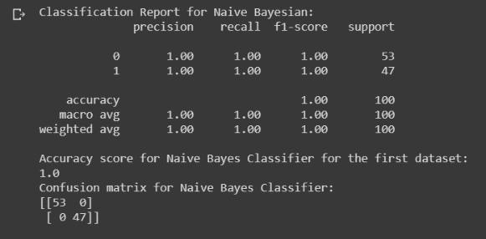metin içeren bir resim

Açıklama otomatik olarak oluşturuldu Naïve Bayes Result with first dataset Logistic Regression result with first dataset

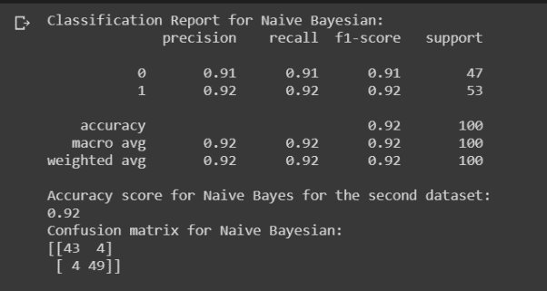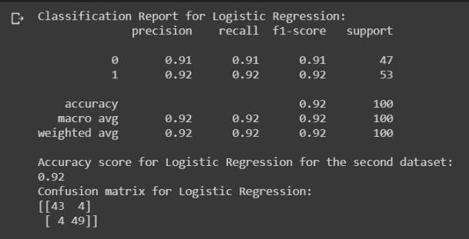 Naive Bayes Result with second dataset Logistic Regression result with second dataset

b) 10pts - Discuss the reason behind why Gaussian Naive Bayesian works better for artificial dataset with the concept of conditional independence.

GNB algorithm assumes that all the features in dataset are conditionally independent from each other and since the features are conditionally independent meaning that there is no correlation between the variables and they are Gaussian distributed in the artificial dataset, Gaussian Naïve Bayesian algorithm’s prediction score is really high on that dataset.

c) 5pts - Draw the perfect decision boundary for the dataset on the scatter plots.

harita içeren bir resim

Açıklama otomatik olarak oluşturulduekran görüntüsü içeren bir resim

Açıklama otomatik olarak oluşturuldu

**Question 2) 20pts –** **Use a Gaussian Naive Bayesian**

Import Kaggle dataset and filter 4 principle topics, Politics, Wellness, Entertainment and Travel. Sample 50000 rows from the data. The occurances of the topics,

POLITICS 8246

WELLNESS 4352

ENTERTAINMENT 3951

TRAVEL 2426

Merge the short_description and headline cells of the corresponding row to use as text to process.

a) 15pts - What is the best test set performance you obtained by Gaussian Naive Bayesian?

The best test performance was nearly 70.93% by Gaussian Naïve Bayesian algorithm. The accuracy performance of the algorithm was decreased compared to the artificial dataset since the features are not conditionally independent in the Kaggle dataset.

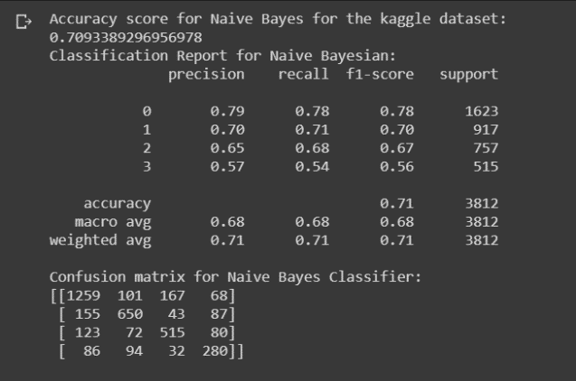b) 5pts – Print the confusion matrix, classification report.

**Question 2) 20pts –** **Use a Logistic Regression**

Import Kaggle dataset and filter 4 principle topics, Politics, Wellness, Entertainment and Travel. Sample 50000 rows from the data. The occurances of the topics,

POLITICS 8246

WELLNESS 4352

ENTERTAINMENT 3951

TRAVEL 2426

Merge the short_description and headline cells of the corresponding row to use as text to process.

a) 15pts - What is the best test set performance you obtained by Logistic Regression?

The best test performance of the Logistic Regression was 89.50%. The algorithm’s accuracy score was really high since it assigns weight to the features and tries to determine relation between the data points. Hence, its prediction result is better than GNB.

b) 5pts – Print the confusion matrix, classification report.

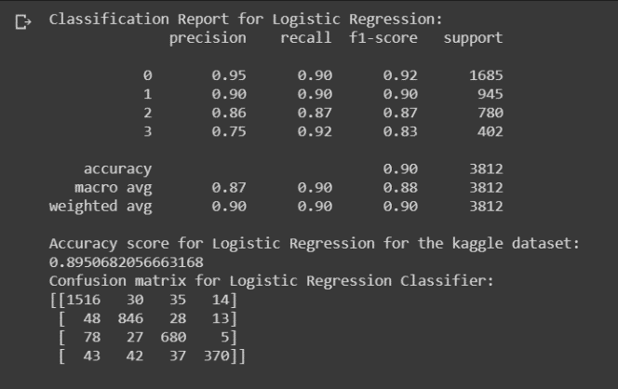

**Question 4) 35pts –** **Report**

**Write a 3-4 lines summary of your work at the end of your notebook**; this should be like an abstract of a paper (you aim for clarity and passing on information, not going to details about know facts such as what logistic regression are or what dataset is, assuming they are known to people in your research area).

“We evaluated the performance of Logistic Regression and Bayes classifiers (Gaussian Naïve Bayes and Gaussian Bayes with general and shared covariance matrices) on the 4 topics of news dataset.

We have obtained the best results with the ….. classifier , giving an accuracy of …% on test data….

You can also comment on the second best algorithm, or which algorithm was fast/slow in a summary fashion; or talk about errors or confusion matrix for your best approach.

**Don’t forget to discuss, Naive Bayesian and Logistic Regression with the concept of conditional independence and decision boundary.**

Note: You will get full points from here as long as you have a good (enough) summary of your work, regardless of your best performance or what you have decided to talk about in the last few lines.

**Link to my Colab notebook (obtained via the share link in Colab):**

[**https://colab.research.google.com/drive/1XuFInknE_7T3aVYoaVv7QQ3HgBz0hyk7**](https://colab.research.google.com/drive/1XuFInknE_7T3aVYoaVv7QQ3HgBz0hyk7)

**Report:**

**We evaluated the performance of Logistic Regression and Bayes classifiers on the 4 topics of news dataset**

**We have obtained the best results with the Logistic Regression classifier, giving an accuracy of 89.50% on test data. The second best algorithm was Gaussian Naive Bayes Classifier giving an accuracy of 70.93% on test data. However, Gaussian Naive Bayes algorithm works faster than the Logistic Regression since it assumes that all the features are conditionally independent from each other and calculates the posterior probability accordingly. On the other hand, Logistic Regression assign weights to every feature and it is more successful for determining the correlation between the features. Hence, it has more complex model and decision boundary compared with the GNB algorithm. However, it is slower than GNB method and it is more likely to overfit. You can access the results of the confusion matrix in the above cells.**

**As the dataset size increases, it is more likely that some features are dependent to each other. Therefore, it is more logical to use Logistic Regression Classifier to get high accuracy scores. However, if you have a dataset in which all the features are conditionally independent to each other, then Gaussian Naive Bayes algorithm would be a better choice since it would work fast and produce very accurate prediction scores.**